Contents

1. Networking Setup 2

2. IAM & Security 6

3. RDS Configuration 8

4. Web Application Layer 9

5. Load Balancer and Auto Scaling 12

6. Static Blog on S3 14

7. Testing 16

8. Conclusion 17

Scenario 2: Secure Business Architecture for a Customer Management Portal

Your company, "ClientLink", is migrating their customer management portal to AWS. You must ensure data confidentiality, scalability, and fault tolerance. The site will be split into a secure backend with RDS and a frontend on EC2 behind an ELB. A static S3-hosted blog will be launched to boost SEO visibility.

# Networking Setup

* + VPC with CIDR 10.0.0.0/16

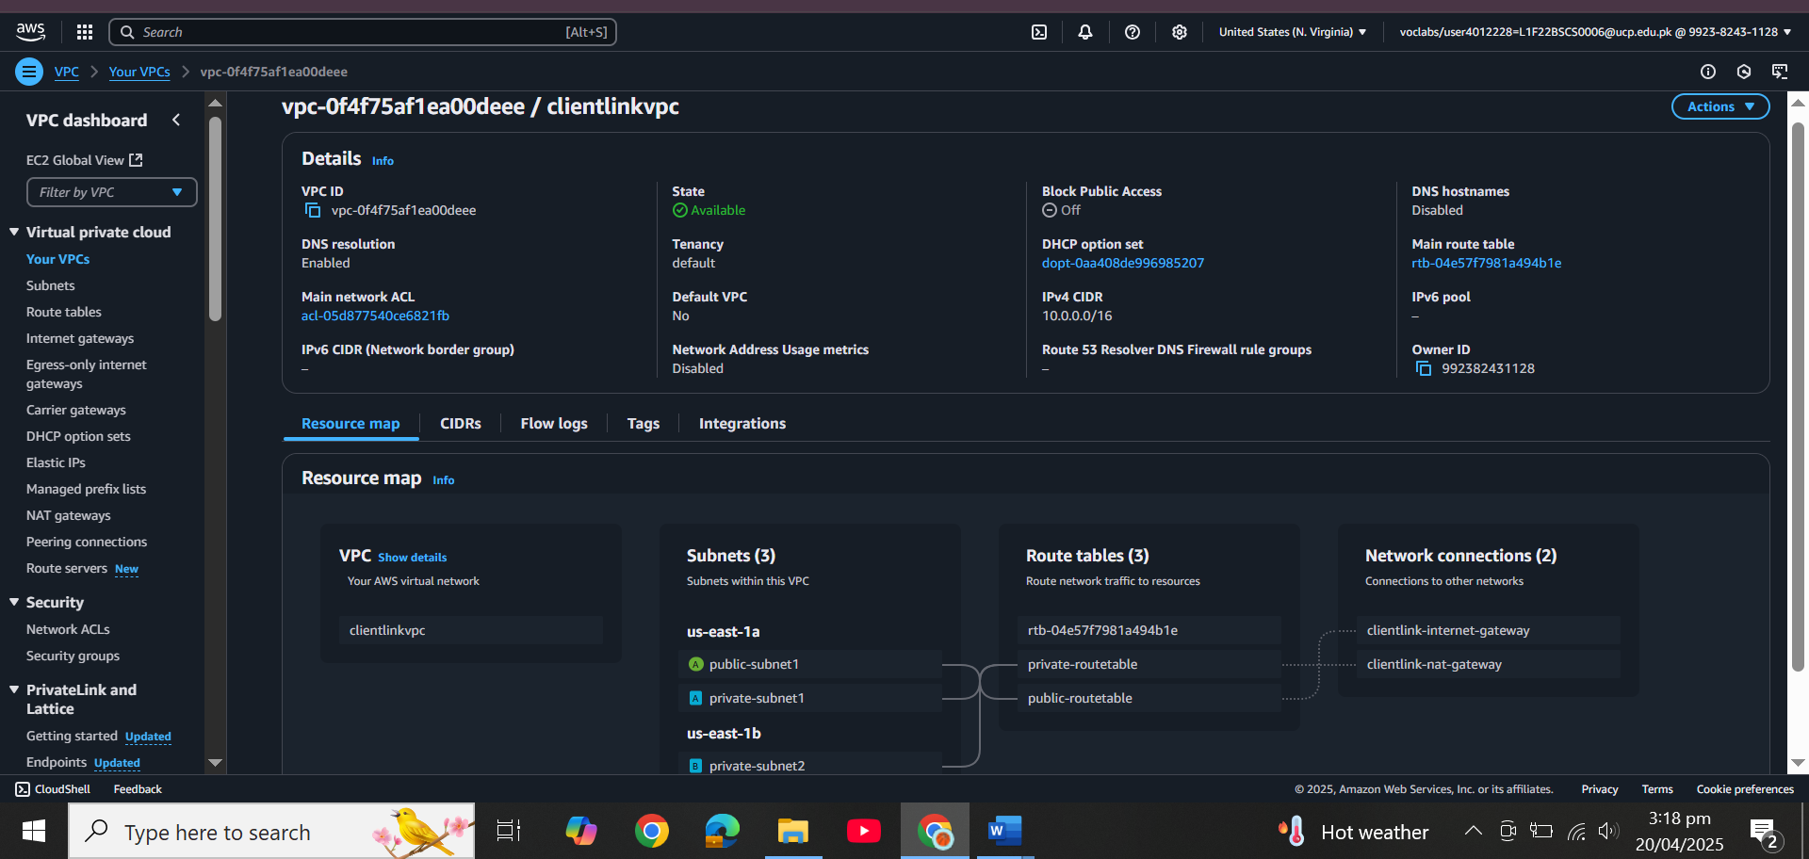

* + 1 public subnet (10.0.0.0/24) and 1 private subnet (10.0.1.0/24)

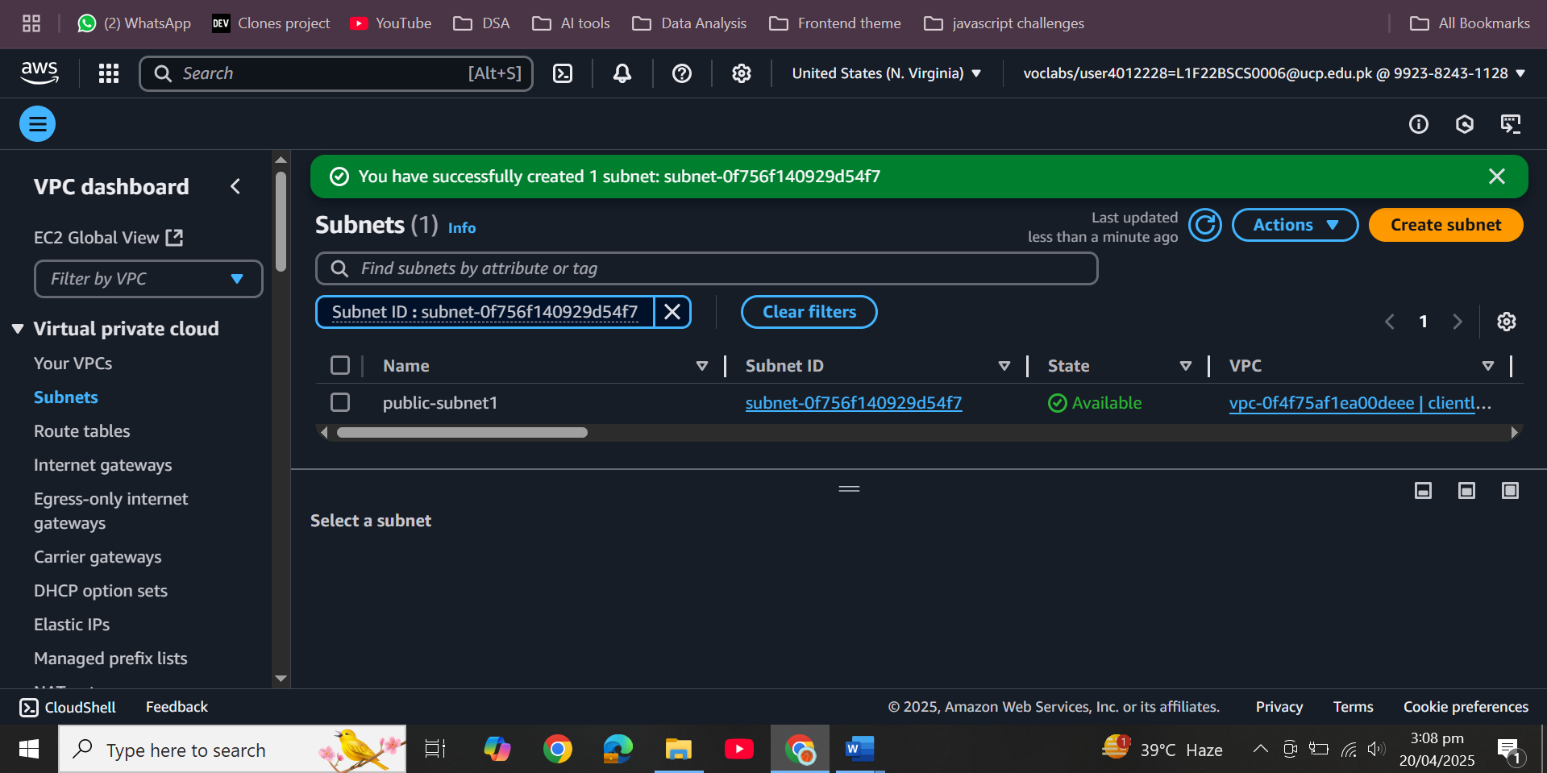  
  
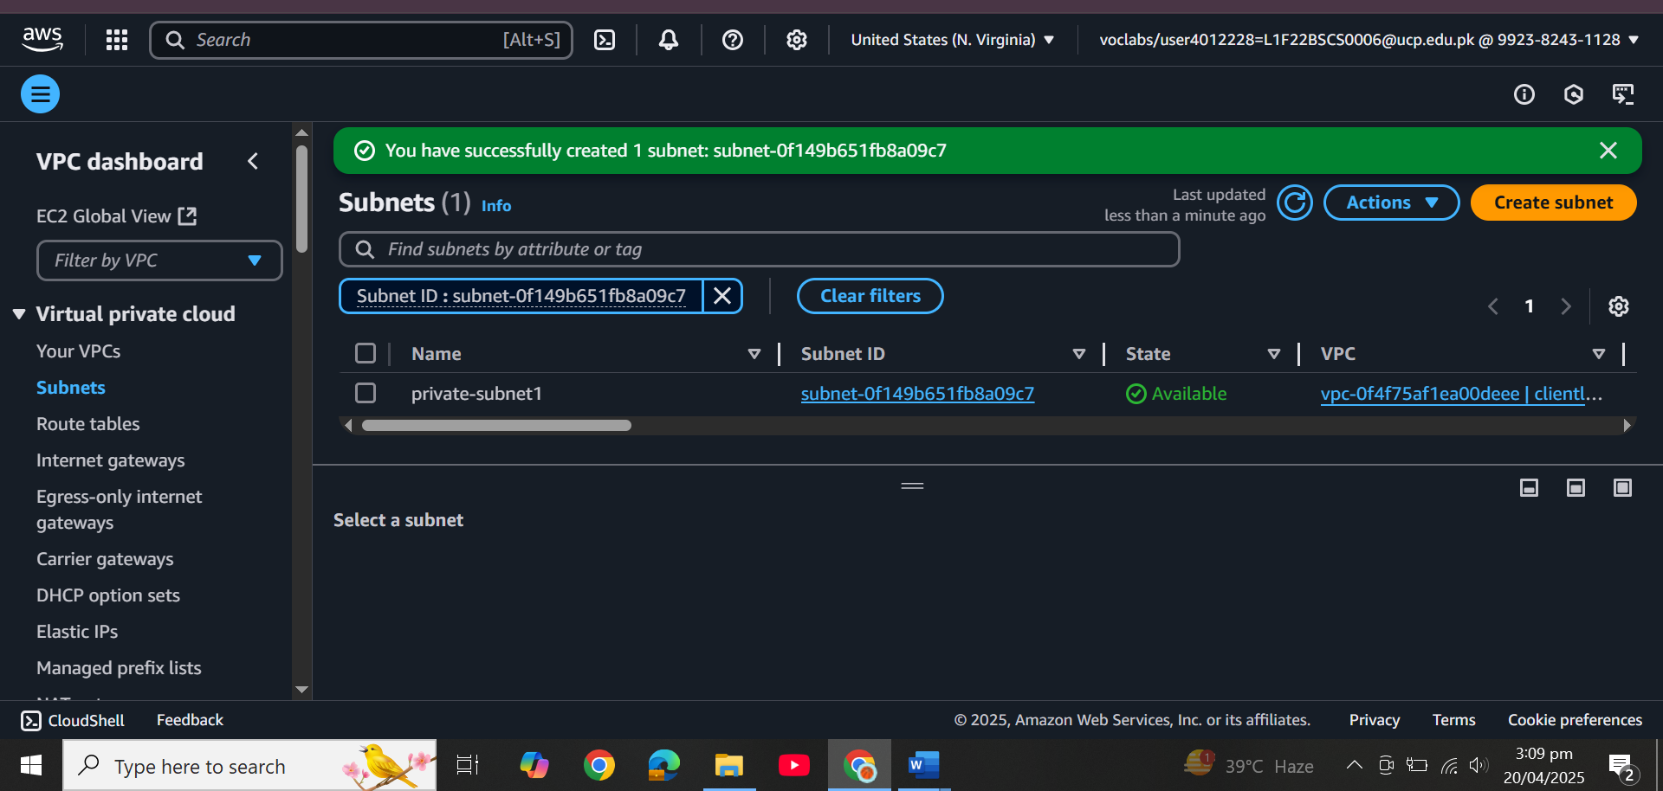  
  
  
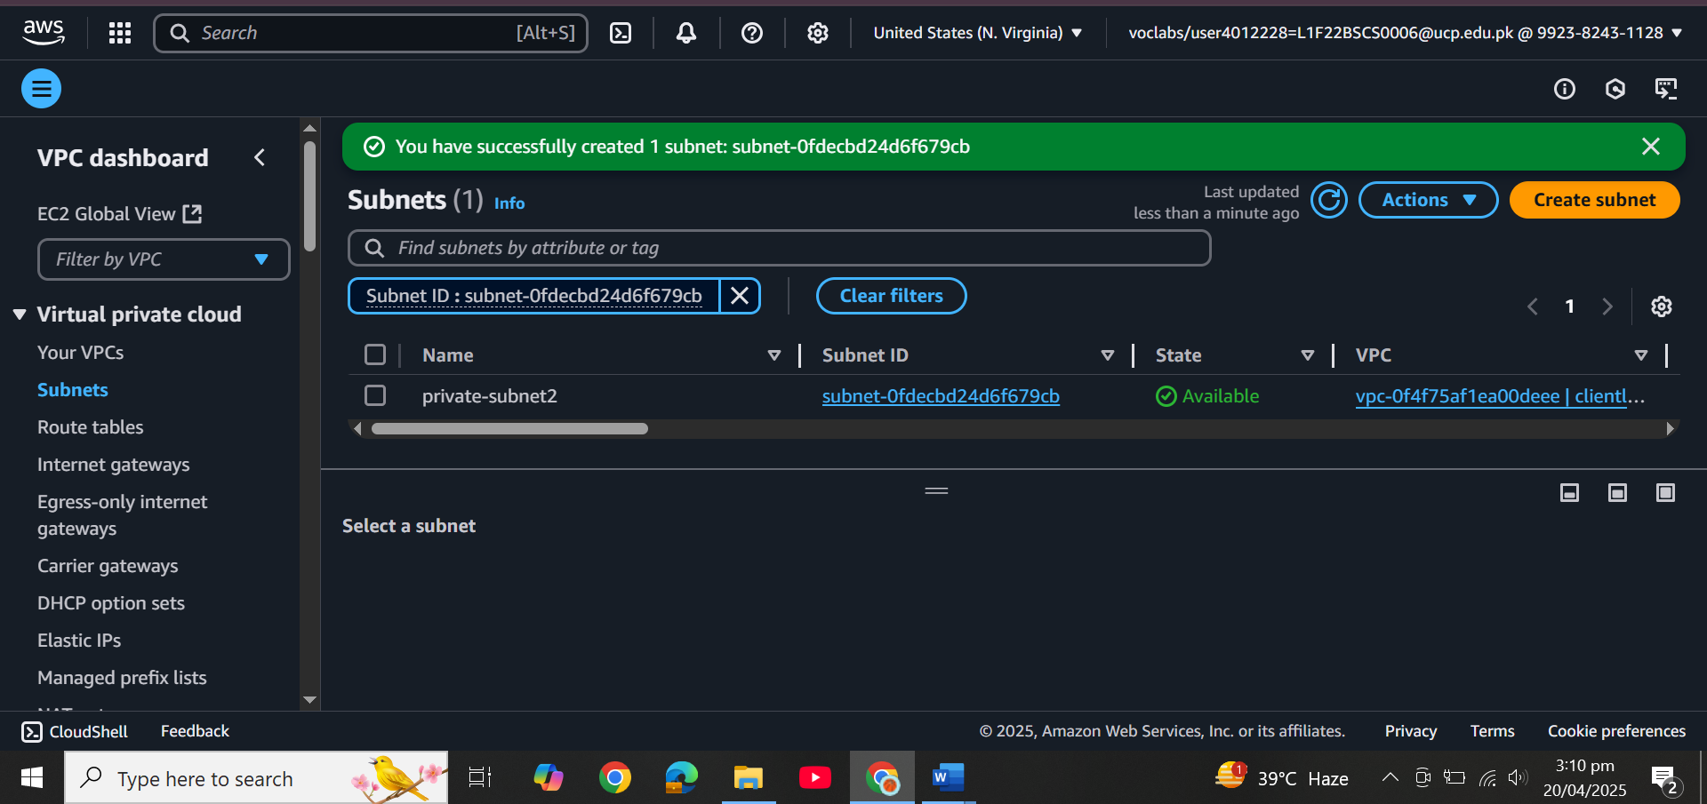

* + Internet Gateway for public access

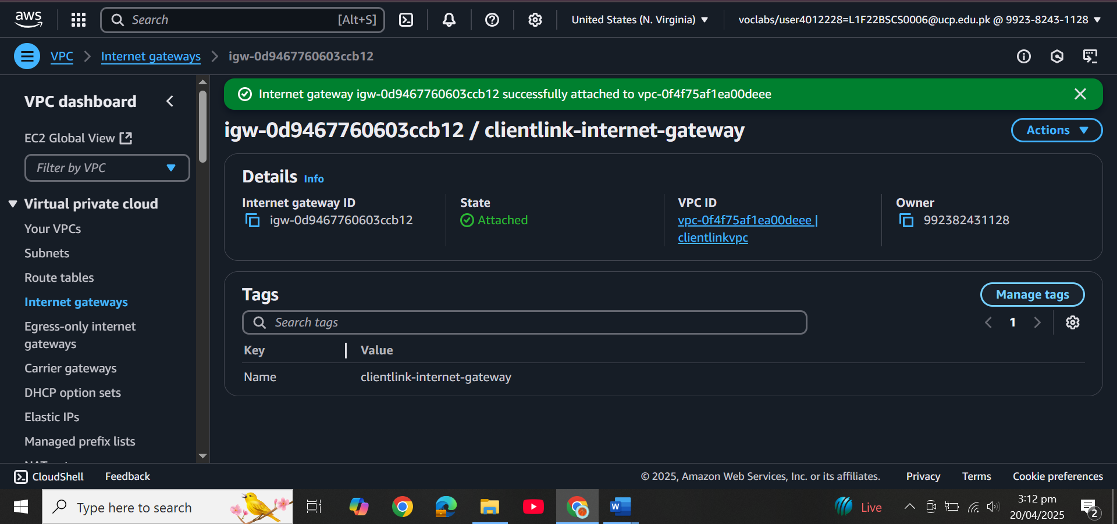

* + NAT Gateway in the public subnet for outbound private subnet access

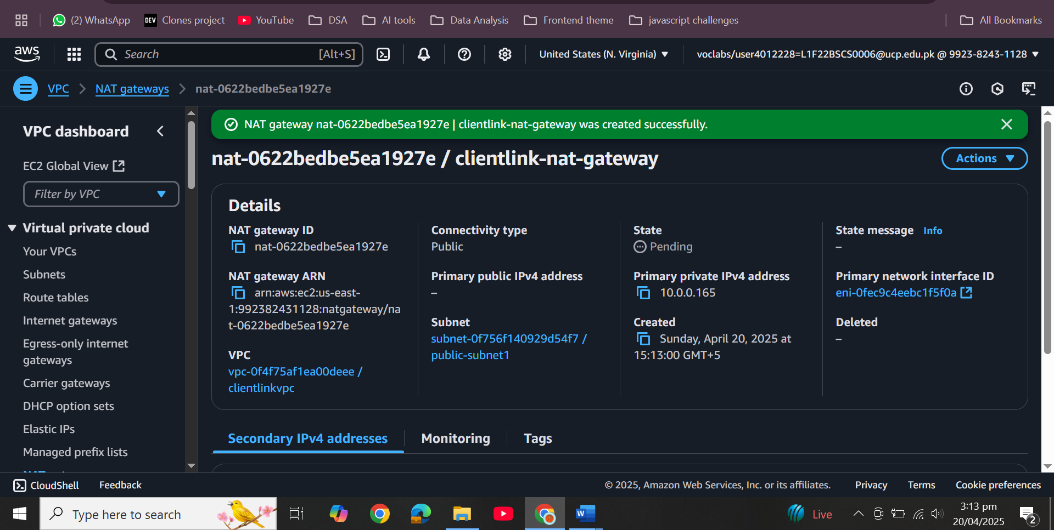  
  
  
  
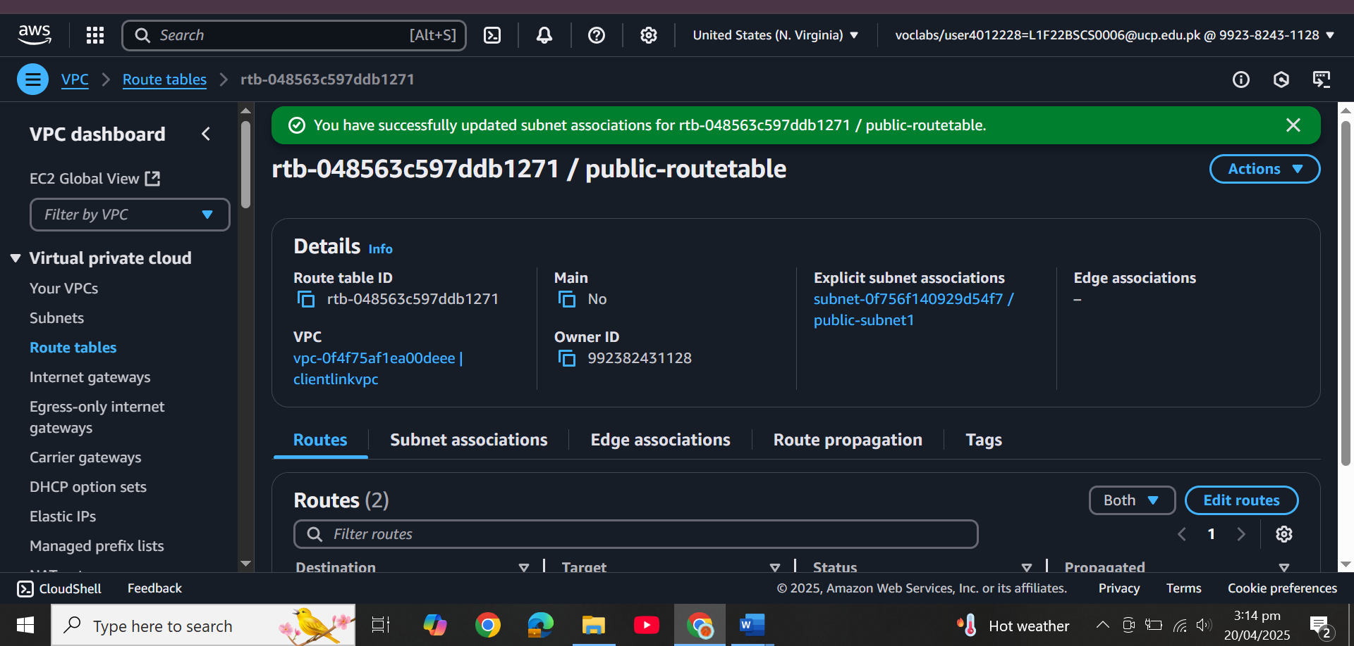  
  
  
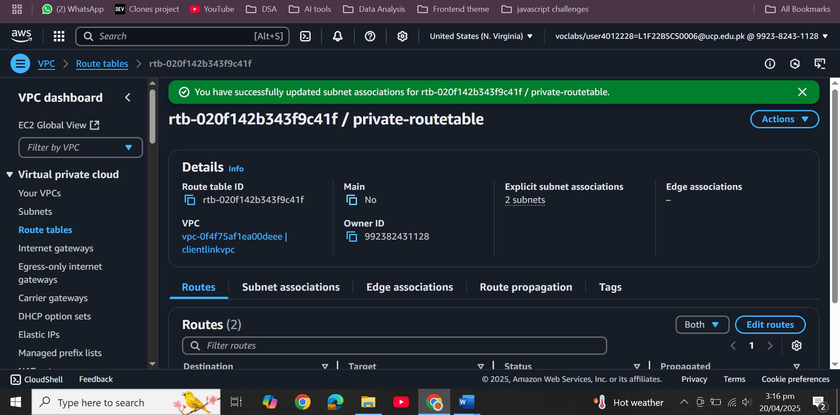

# IAM & Security

* + Create an IAM role for EC2 with AmazonRDSFullAccess  
    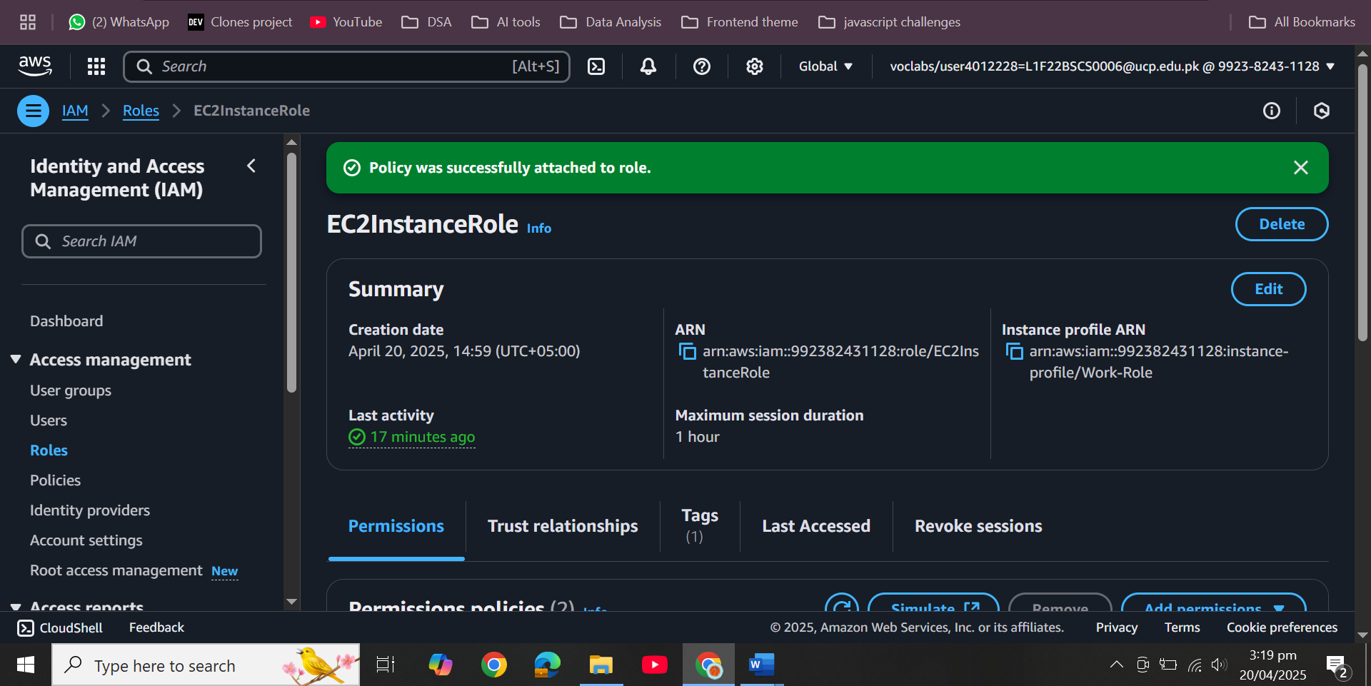
  + Create SGs:
    - FrontendSG: HTTP/HTTPS from 0.0.0.0/0  
      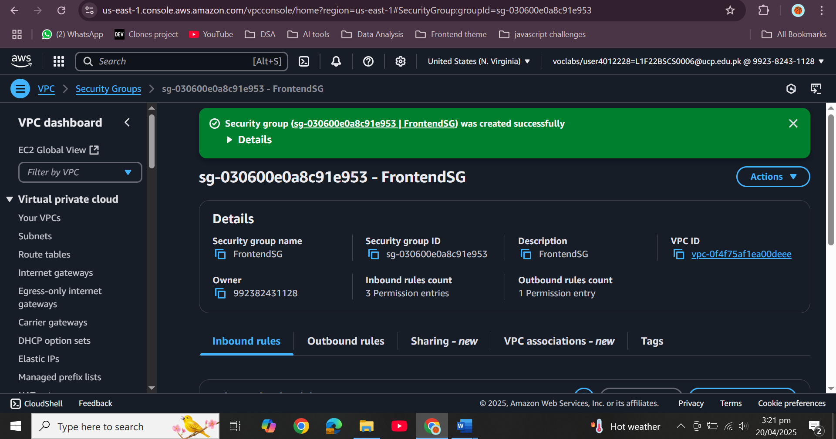
    - BackendSG: MySQL access from FrontendSG only  
      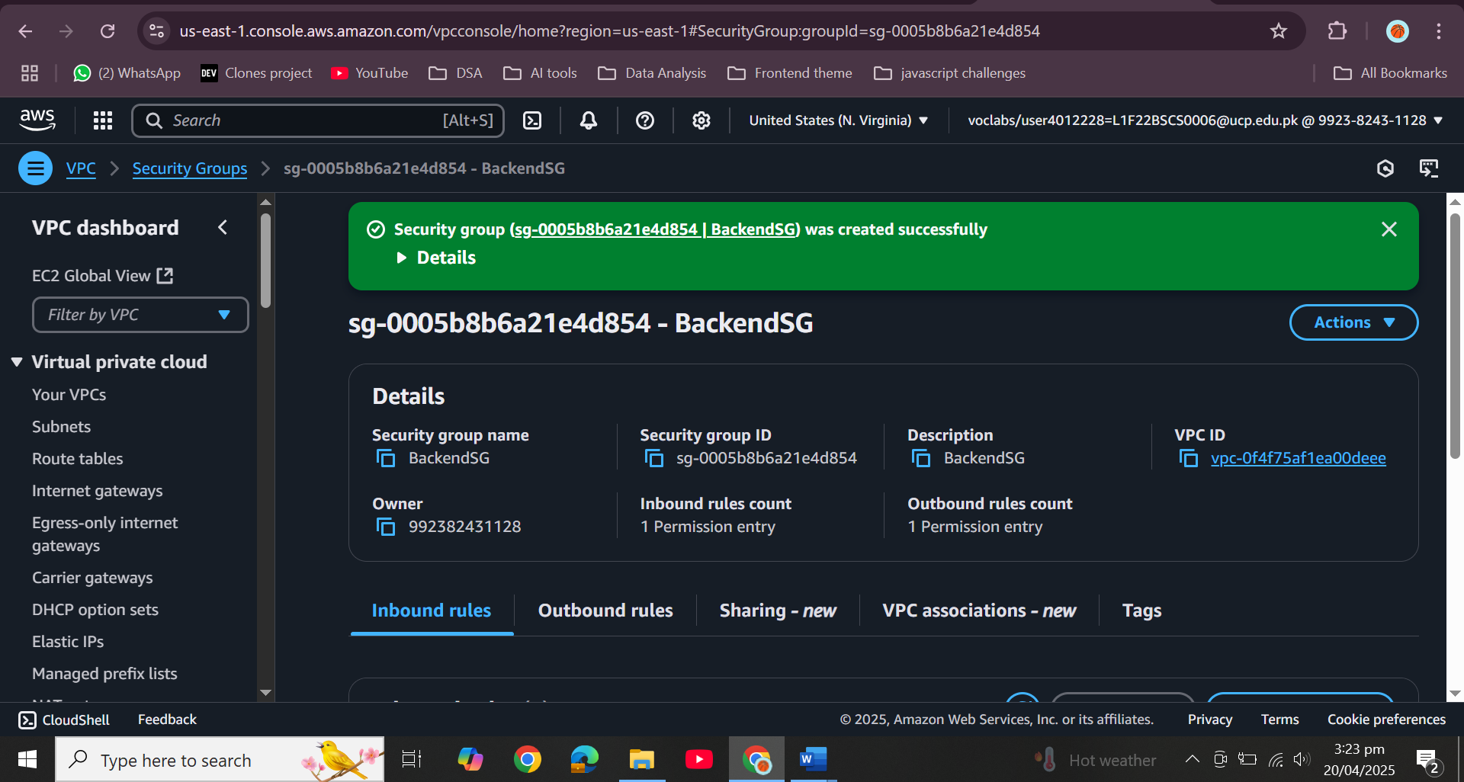

# RDS Configuration

* + MySQL engine, identifier: client-db  
    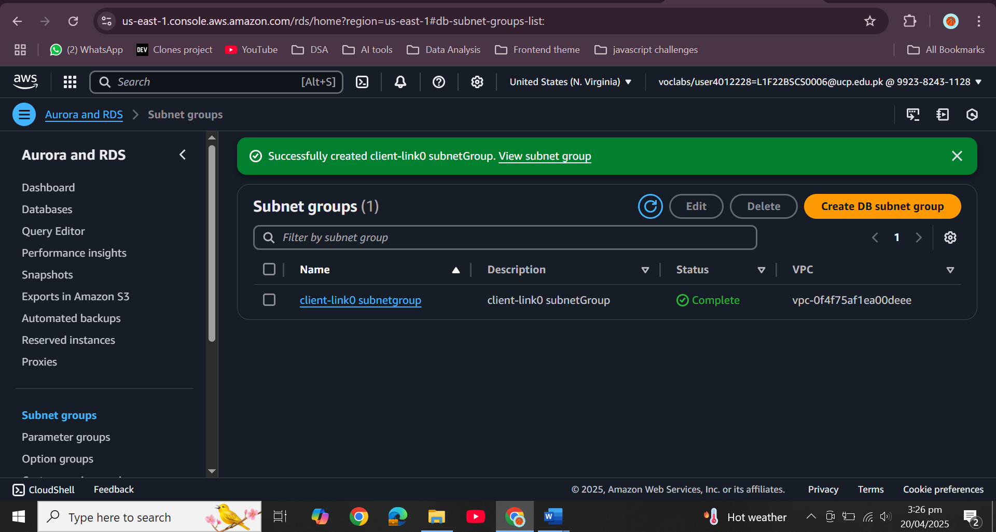  
    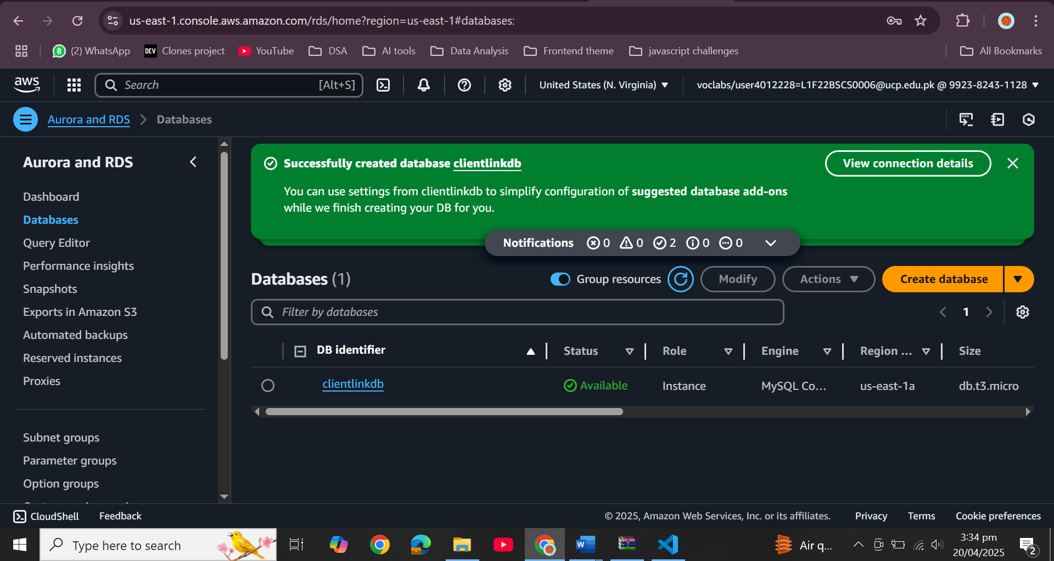
  + Place RDS in private subnet  
    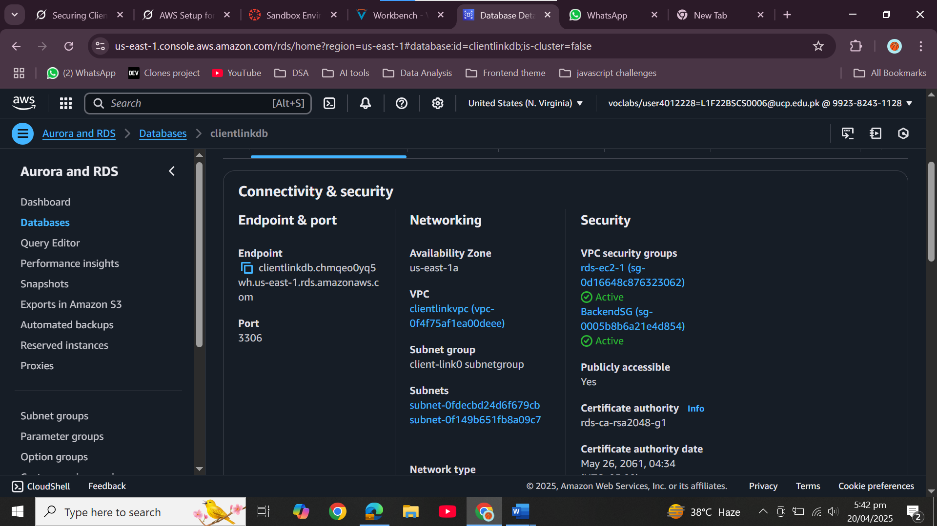
  + Disable backup/encryption for faster launch in the lab

# Web Application Layer

* + Create EC2 instance in the public subnet  
    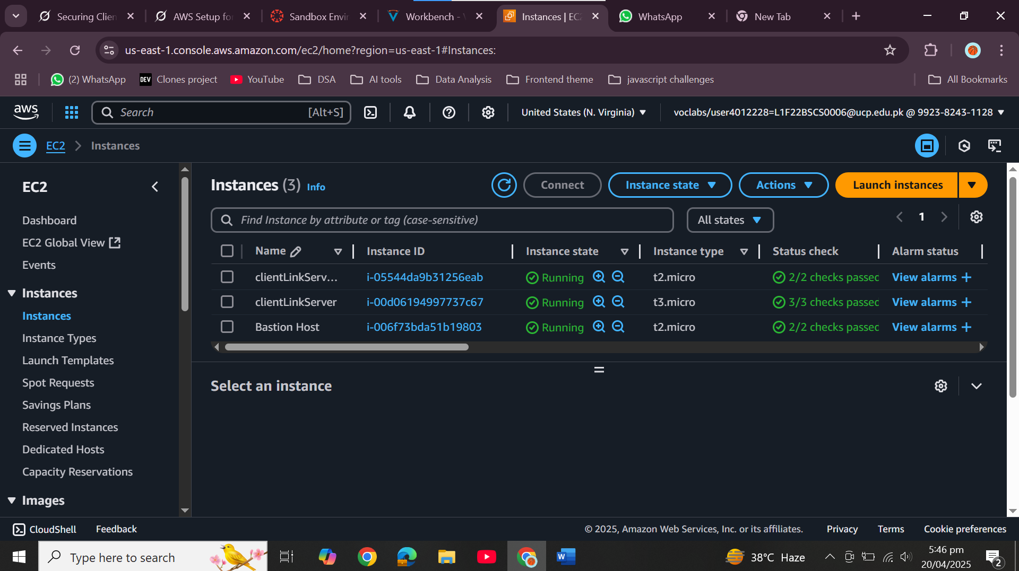
  + Use a user-data script to:
    - Install Apache, PHP, unzip, etc.
    - Download and unzip web application from lab-app-php7.zip  
      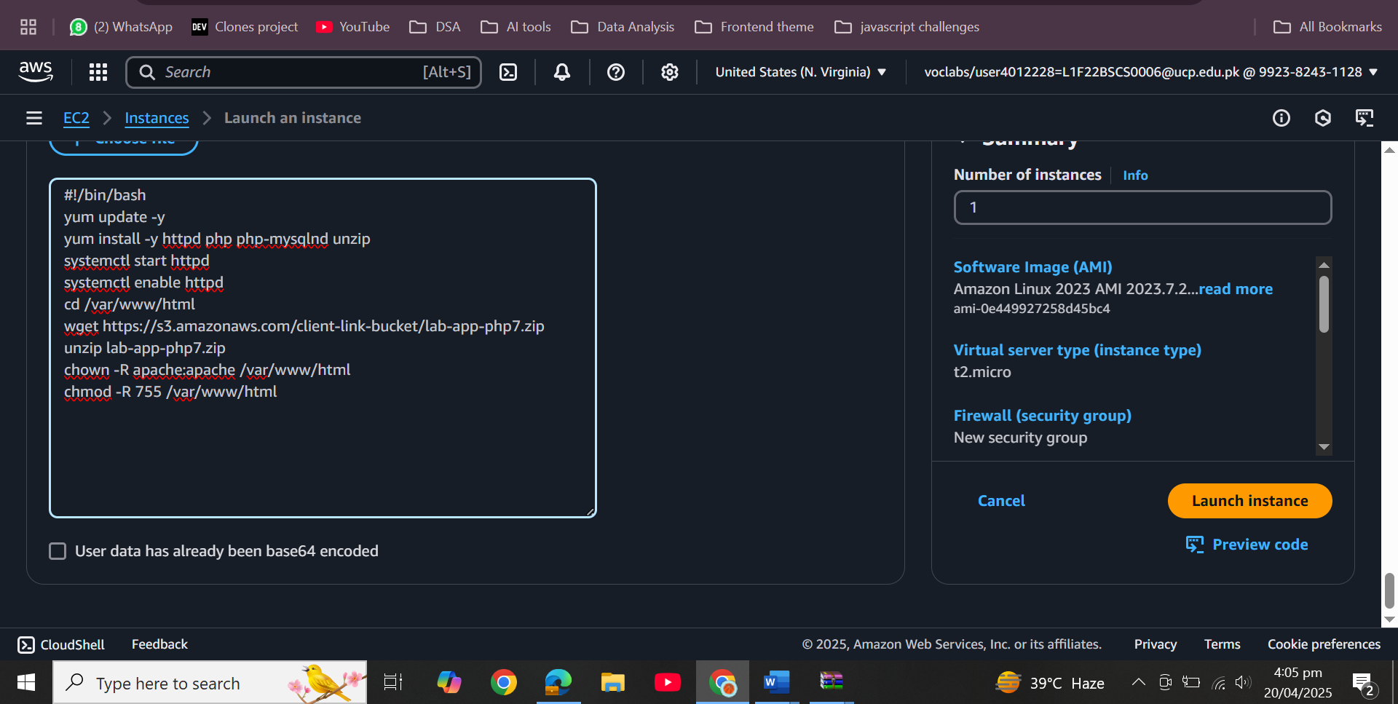
    - Configure RDS connectivity  
        
      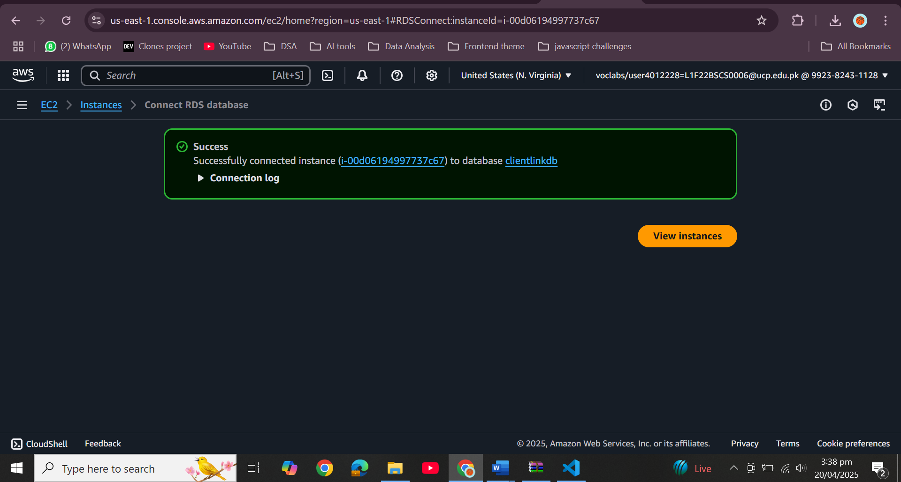  
        
      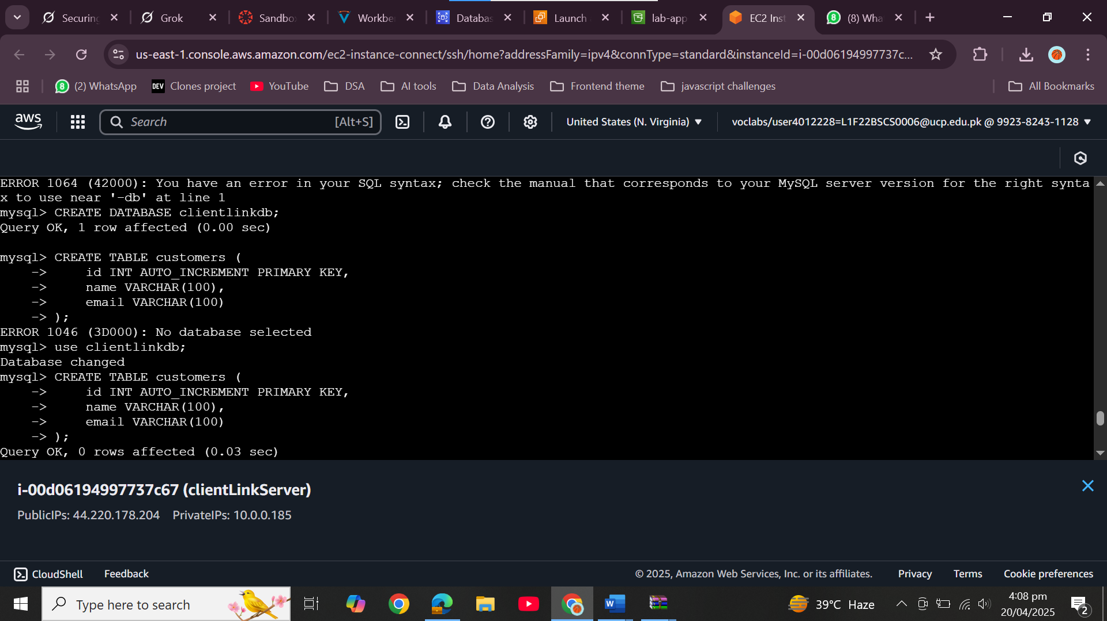  
        
        
      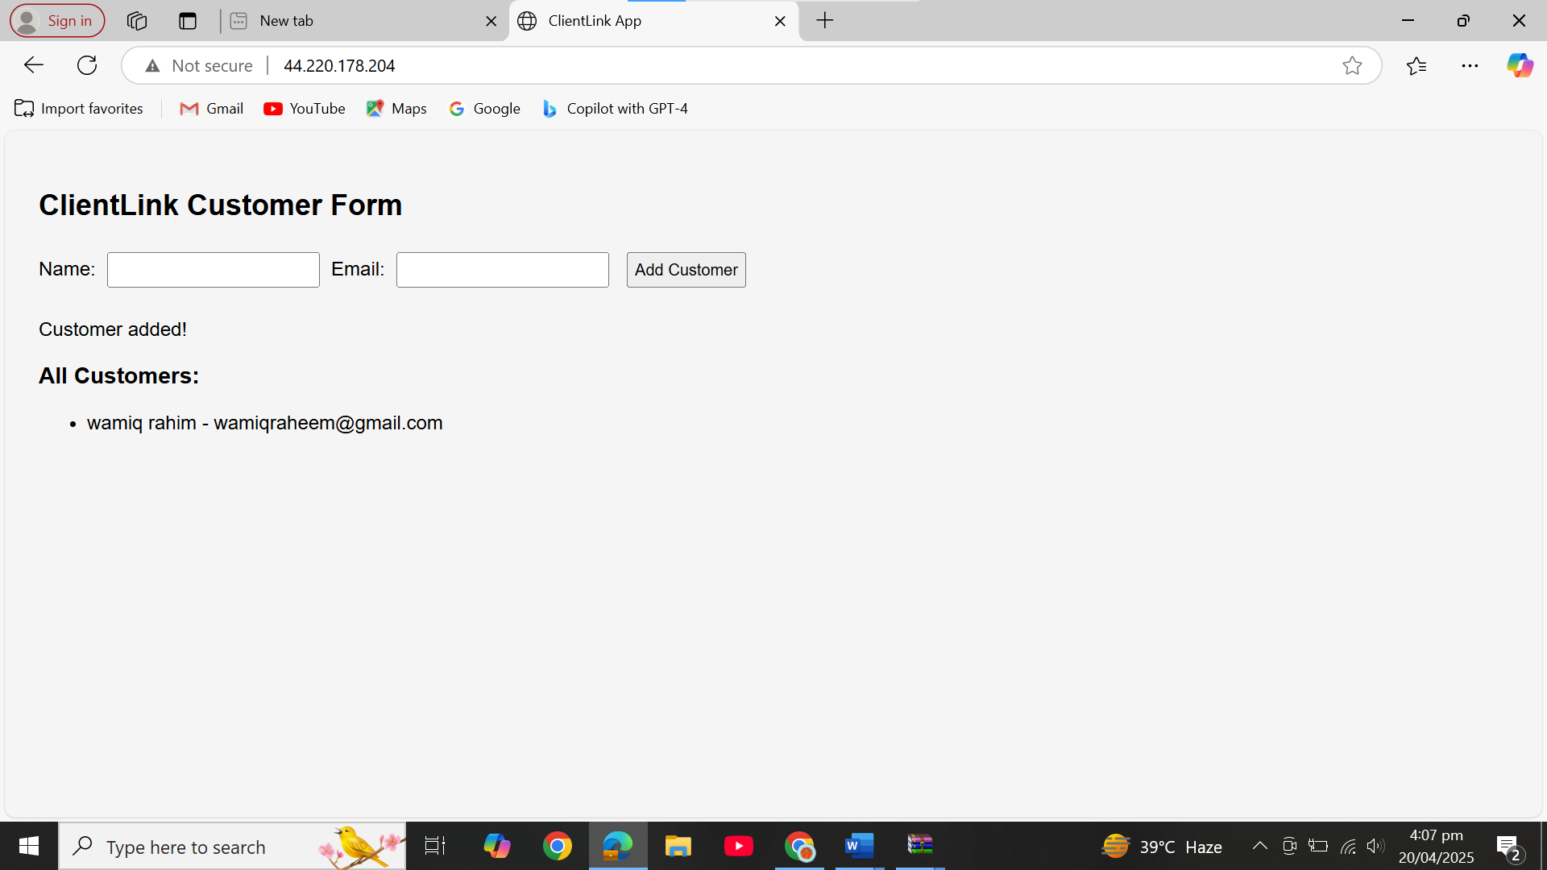  
        
      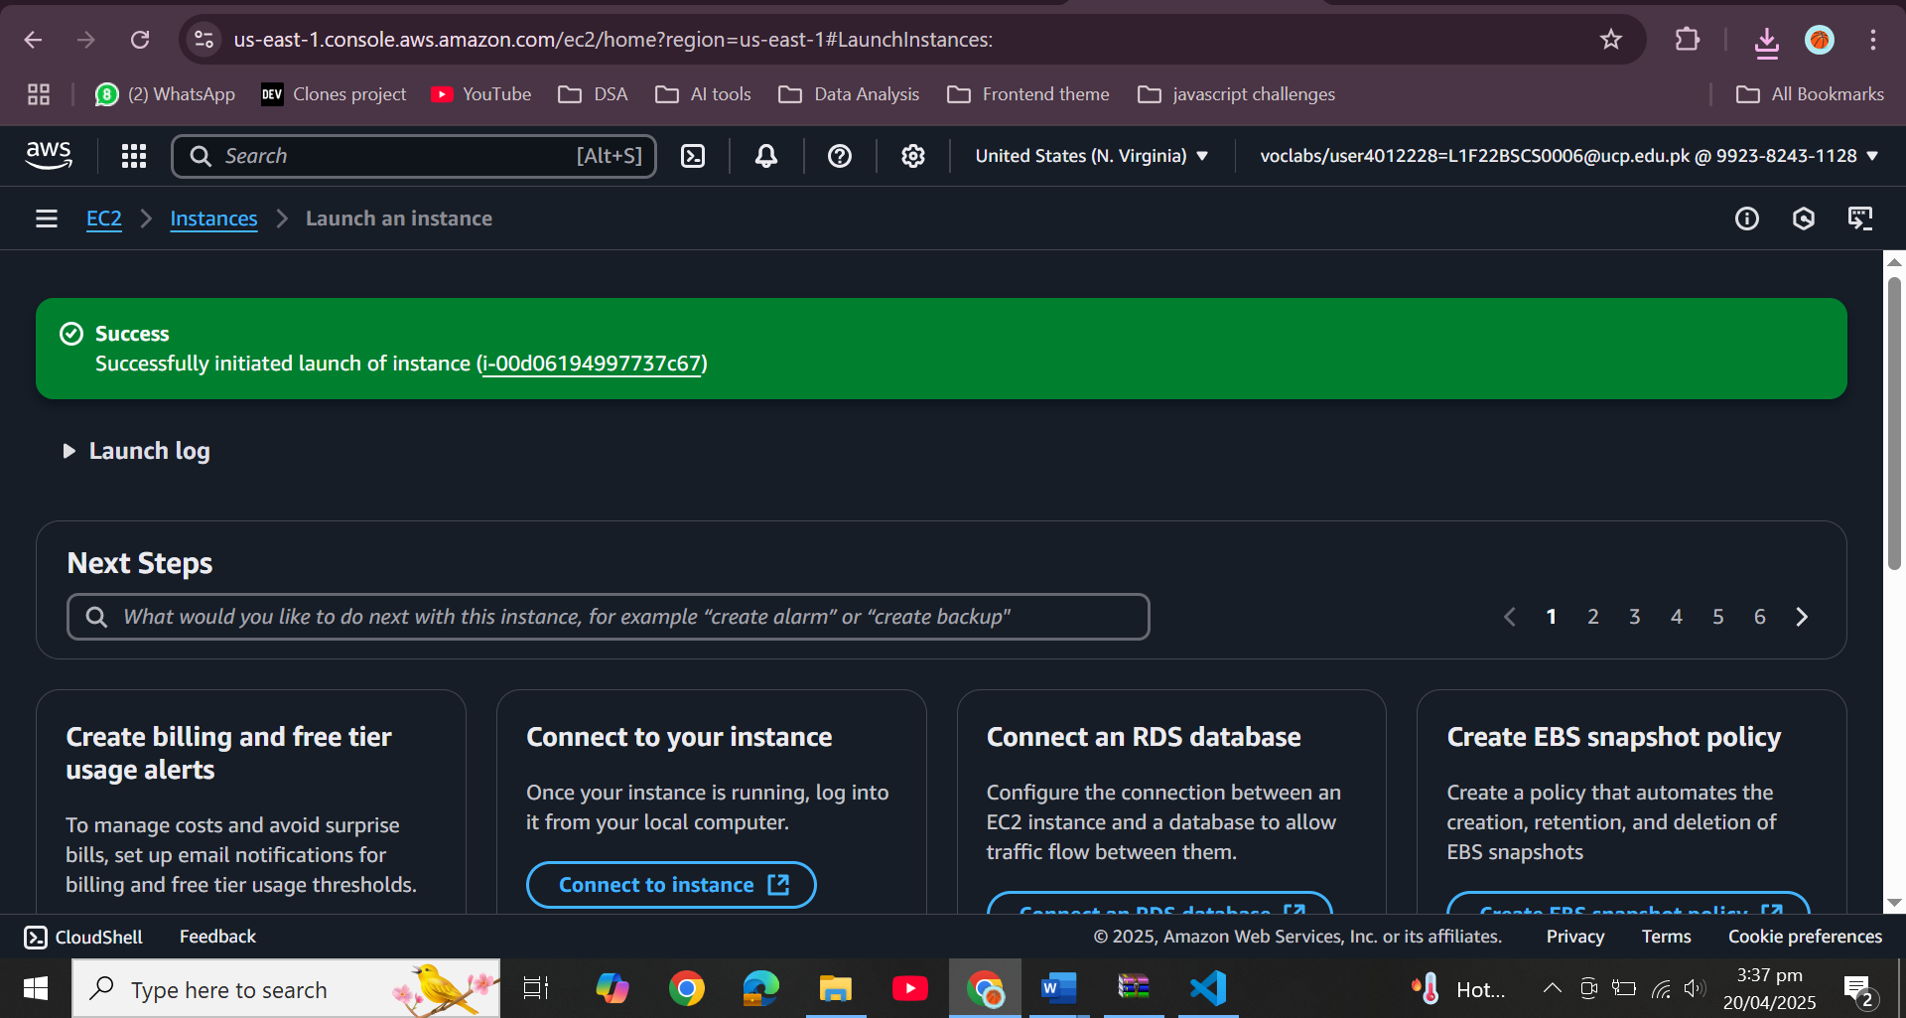

# Load Balancer and Auto Scaling

* + Create an AMI from EC2  
    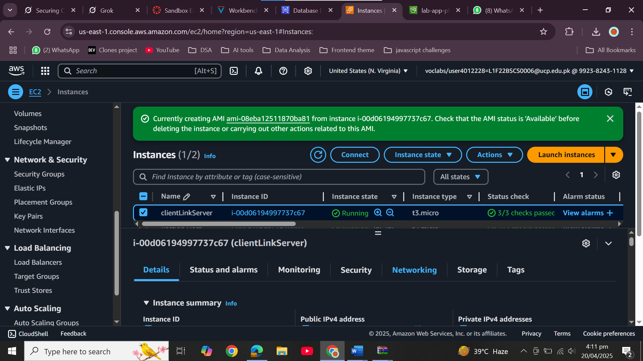
  + Launch Template → ASG (Min: 1, Max: 4)  
      
    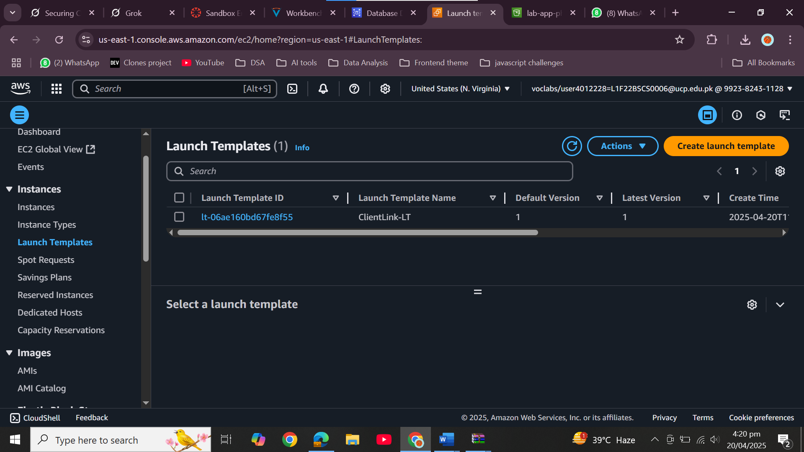  
      
    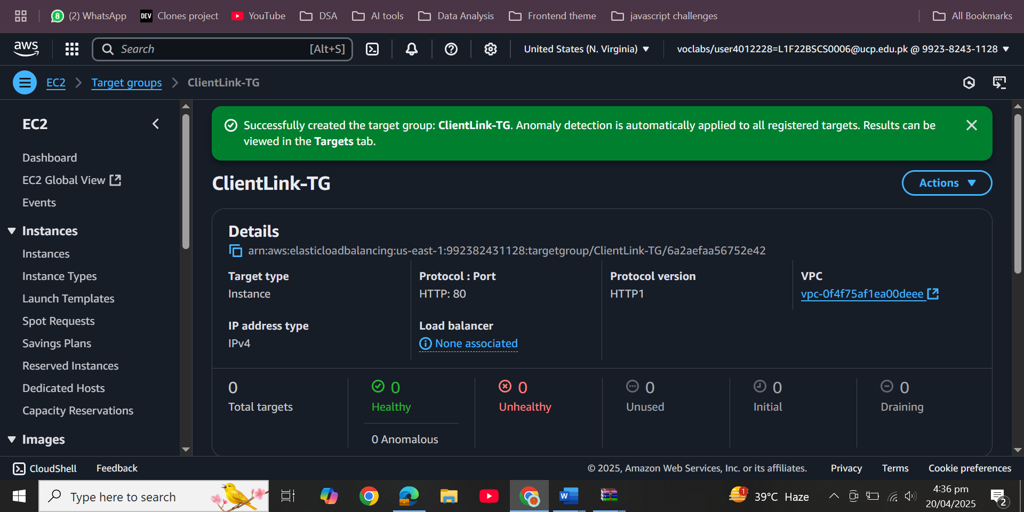  
      
    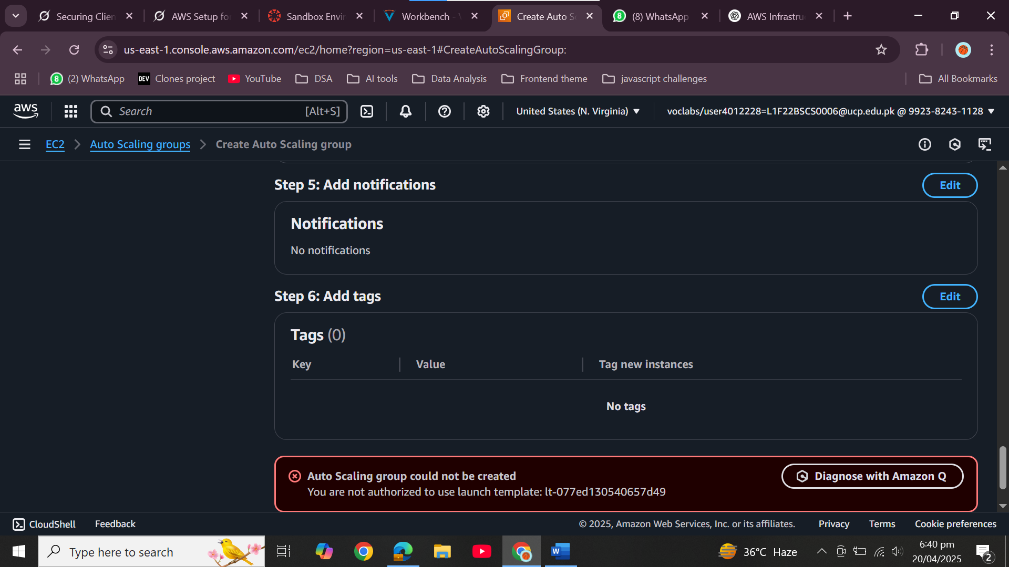
  + Attach to Application Load Balancer  
    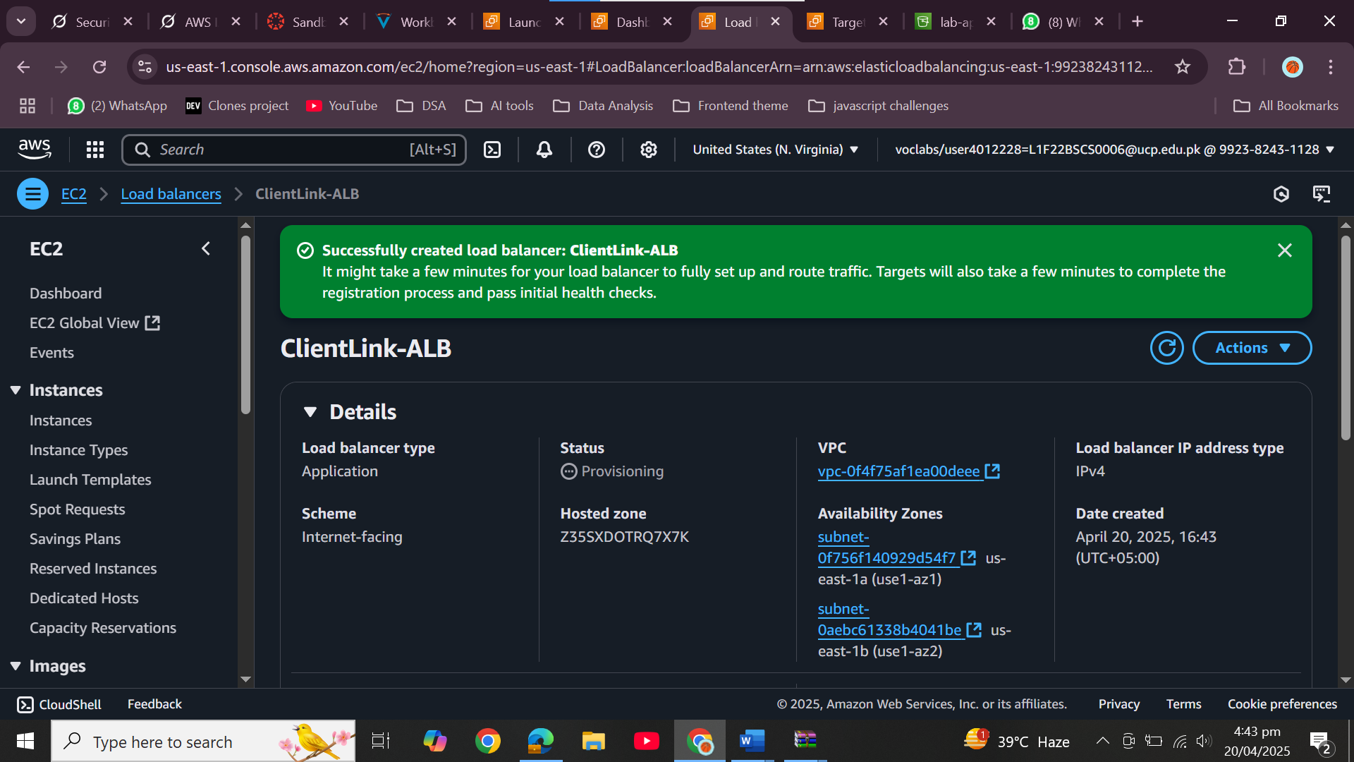
  + Add CloudWatch alarms for scaling based on CPU

# Static Blog on S3

* + Create and configure an S3 bucket for static website hosting  
    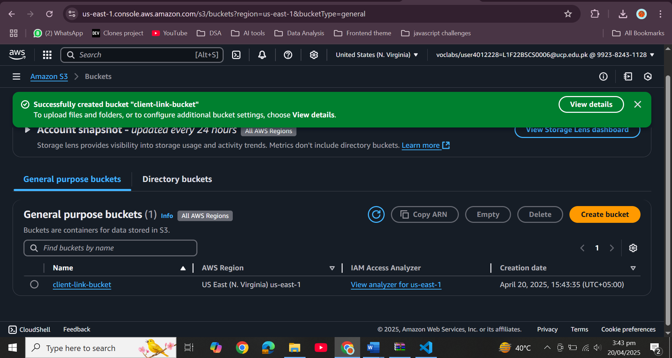
  + Upload blog HTML files from static-website-crn.zip  
    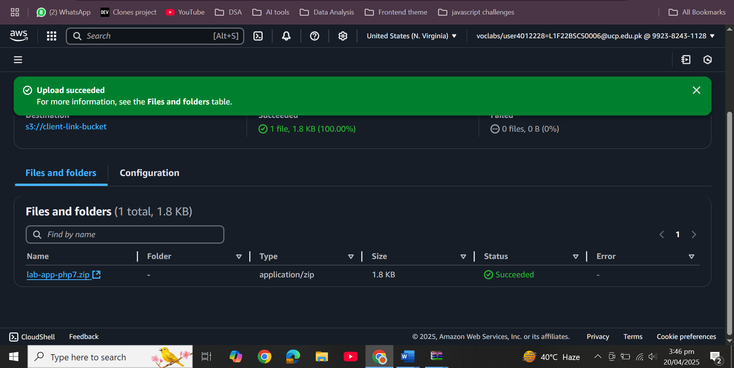
  + Add public read bucket policy  
    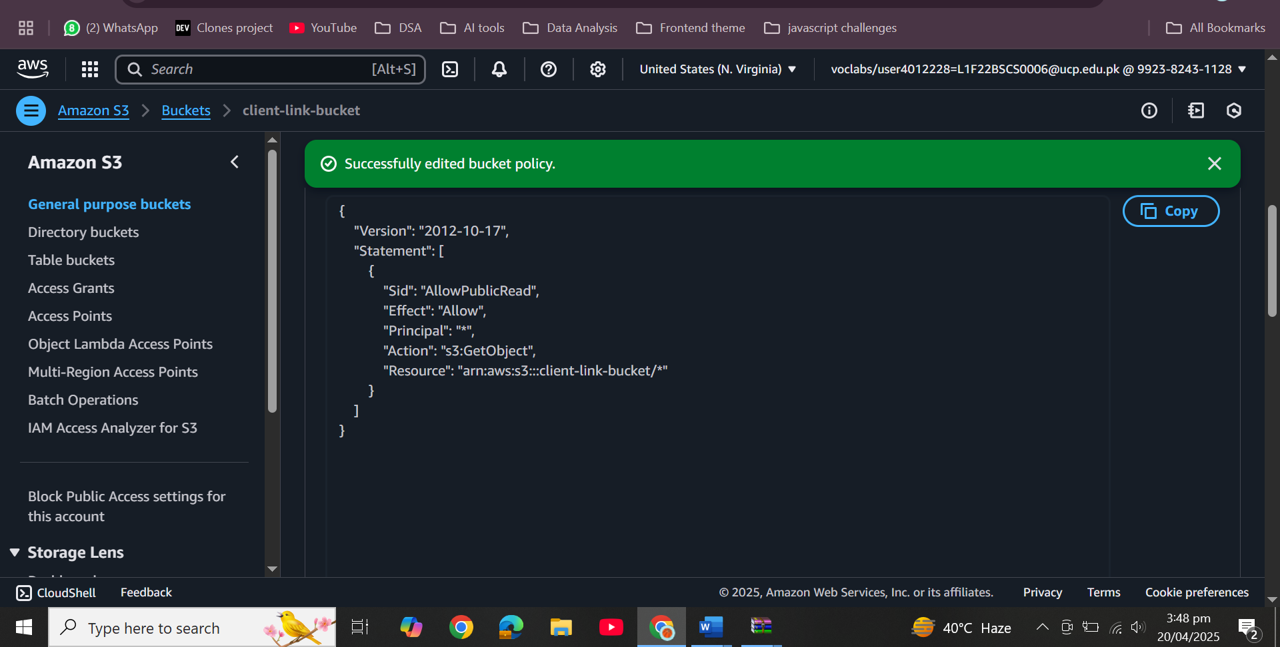

# Testing

* + Access web application via Load Balancer DNS  
    
  + Validate database connectivity and ability to add/view customer data  
    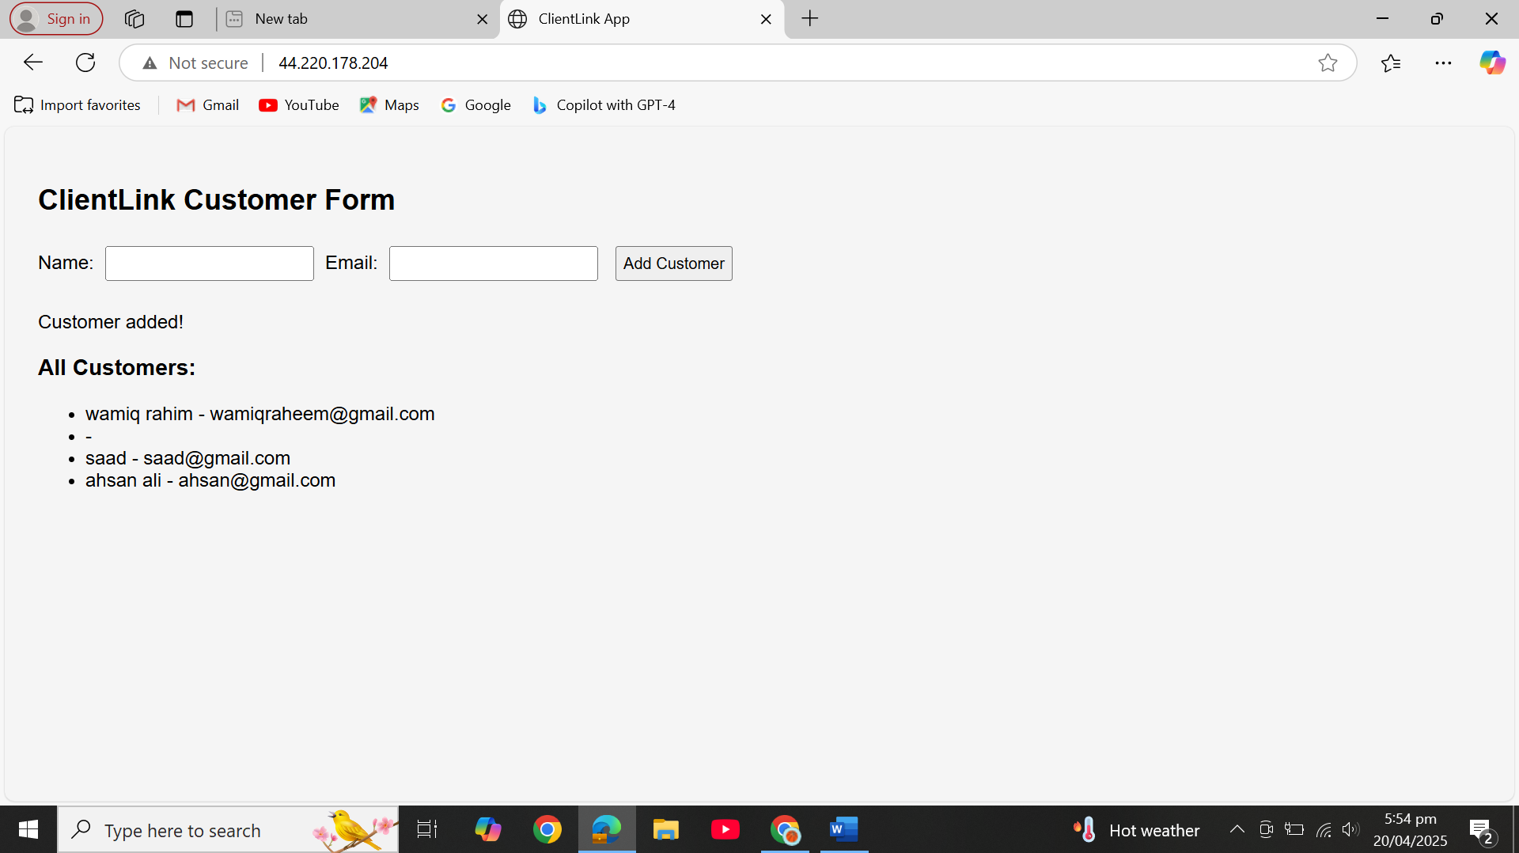

# Conclusion

1. **Networking Setup**

Designed a secure, scalable network using Amazon VPC with public and private subnets. Internet Gateway provided outbound access for public instances; NAT Gateway did the same for private ones.  
*Result: Isolated, well-structured network deployed.*

1. **IAM & Security Groups**  
   Configured IAM roles for EC2-RDS access and set up Security Groups:
   * *FrontendSG*: Allowed HTTP/HTTPS/SSH.
   * *BackendSG*: Allowed RDS access from FrontendSG only.

*Result: Strong identity and traffic control in place.*

1. **RDS Setup**  
   Launched an Amazon RDS MySQL instance in the private subnet. Created a labdb database with a customers table.  
    *Result: Secure backend database deployed.*
2. **EC2 & Web App Deployment**  
   Deployed a PHP web app on EC2 in the public subnet using a user data script. Connected the app to the RDS instance.  
   *Result: Frontend and backend fully connected and functional.*
3. **Load Balancer Integration**  
   Manually deployed EC2 and linked it to an Application Load Balancer with a configured target group and health checks.  
   *Result: Load-balanced access successfully implemented.*
4. **Static Blog Hosting (S3)**

Enabled static website hosting on S3 and uploaded HTML/CSS files. Set public-read permissions.  
*Result: Blog accessible via S3 website URL.*

**7. Testing**

* ALB routes traffic to EC2
* Web app interacts with RDS
* S3 blog renders properly

*Result: Full system tested and working.*